Magic 100 words

Dear Parent/Caregiver,

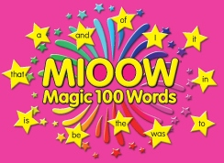

Magic 100 Words is a program that all students in Kindergarten take part in at Seven Hills West Public School. This will be their homework for Semester One.

The program involves literacy activities and games that promote the instant recognition and processing of words, known as automaticity. Automaticity significantly improves reading fluency and flexibility. When students master half the words used in reading and writing, the task of reading and writing is ‘magically’ easier.

Your child has a coloured card containing words for them to learn. Each week as a part of homework, students will be assessed on their ability to recall the words instantly.

Once your child can recall all of the words on the coloured card with automaticity, they will receive an award to celebrate their achievement and will collect a different coloured card with new words to learn. If you child cannot recall all words, they will be given the same coloured card for the following week to continue to practise.

We encourage you to practise the words daily with your child to assist them in the process of learning the Magic 100 Words. It should be a short sit down with your child and try to keep it fun.

Ms K Becker Miss A Craig, Mrs K Gardiner,
Principal Miss R Pizarro & Mrs A Zollinger
04.03.19 Kindergarten Class Teachers

