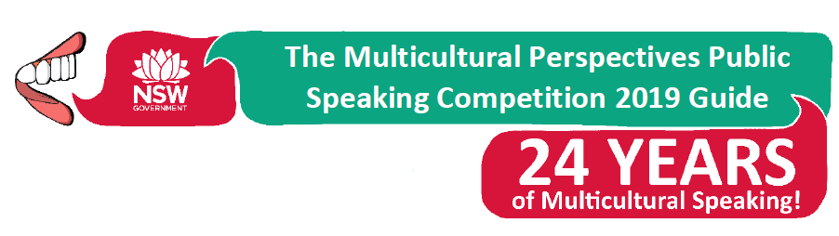

Dear Students, Parents and Caregivers,

In Term 2, students in Years 3-6 will need to prepare a speech to present to their class as a part of the Multicultural Perspectives Public Speaking Competition. This competition gives students the opportunity to practise their public speaking skills, heighten their awareness of multicultural issues and improve their confidence in public speaking. This term, students participated in immersion centres created by the classroom teachers to support their knowledge and understanding of the topic and how to write an effective speech. These centres allowed them to delve deeper into the topics listed below by engaging with a variety of sources chosen to spark student’s interests.

This learning experience is a combination of work to be completed both at school and at home. Students will be given a criteria of things to work on both at school and at home and this will guide the assessment rating for each presented speech which is attached.

Two students from each class will be chosen to participate in an internal School Final. From this, one student from each year will be chosen to represent our school in the Multicultural Perspectives Public Speaking Local Final. Speeches are due on Tuesday 7th May (Week 2, Term 2) to the classroom teacher. Parents are welcome to attend the School Final on Friday 24th May (Week 4, Term 2) at 11:30am in the School Hall.

Parents are welcome to assist students with their speeches, however we are hoping most of it will be completed at school, and the students practise the speech themselves and are able to present it on their own which is a great task to be worked on at home. The speech should be written on palm cards that can fit inside the student’s hand. Students are encouraged to incorporate their own personal experiences in their chosen topic.
Students in Year 3 and 4 will need to speak for 3 minutes. Students in Years 5 and 6 will need to speak for 4 minutes on any one of the following topics:

Year 3 and 4 Topics | Year 5 and 6 Topics
- Playing together  - Multiculturalism in the media  - Watch your language!  - Refugees  - Kid power!  - Belonging  - Every child matters  - Understanding  - What makes an Australian?  - Our backyard  - Multiculturalism at school | - Welcome to Australia  - Human rights and wrongs  - Australia Day  - Colour-blindness  - Being a global citizen  - What would Captain Cook say?  - Sport and Multiculturalism  - Learning from the past  - Australia on the screen  - It’s complicated  - Getting a multicultural education
As this learning experience is a formal assessment, the learning at school and practice at home is vital! If you have any questions, please speak to your child’s classroom teacher.

Ms K Becker Mrs P Jade-Pierce Mrs N Franciscus & Mrs N Rosario
Principal Assistant Principal Public Speaking Coordinators
08.04.19

